**GENERAL HUMAN BIOLOGY – YEAR 11**

**TASK 11 – PREGNANCY AND BIRTH TEST**

**NAME: _______________________________________ WEIGHTING: 10%**

**TOTAL = ______/ 43**

***MULTIPLE-CHOICE [5 MARKS]***

|  |  |
| --- | --- |
| **1.** | D |
| **2.** | D |
| **3.** | A |
| **4.** | D |
| **5.** | B |

***SHORT ANSWERS [18 MARKS]***

1. Immediately following fertilisation, the zygote begins to divide to form a solid ball of cells. As cell division continues, the cells arrange themselves into a hollow ball of cells as seen in the micrograph image below:



What is the name given to this hollow ball of cells ? [1 mark]

* Blastocyst

1. The human placenta averages 22cm in length and 2-2.5cm in thickness. It typically weights 500gm. A human placenta can be seen with the umbilical cord still attached at the top:

[TOTAL = 6 MARKS]



1. Describe two functions of the human placenta [2 marks]

* Transports oxygen / nutrients
* Strores nutrients for later stages of pregnancy
* Secretes hormones to maintain pregnancy
* Transports carbon dioxide / wastes
* Transports antibodies

The umbilical cord connects the foetus to the placenta. Inside the umbilical cord are two vessels – the umbilical artery and umbilical vein.

1. In the diagram below draw the direction that blood flows through these two vessels between the foetus and the placenta. [2 marks]

* Vein: from mother to foetus
* Artery: from foetus to mother

1. Jacinta and T-Ana were looking at the Human Biology syllabus and read the following statement:

***“Pregnancy will be established only if implantation occurs and the placenta is formed and maintained”***

The girls are confused by this statement. What could you say to the girls to explain importance of maintaining the placenta during the entire pregnancy? [2 marks]

* Not supplying / removed (1)
* The effect (1)

*Eg.*

* Placenta is needed to provide nutrients / remove wastes
* If it becomes detached then foetus is no longer going to be supplied which may result in the loss of the foetus / death / malformation / disability

1. Put the following statements into the correct order based on what month they occur in; in relation to development and changes during pregnancy. They are already in the correct trimester. [TOTAL = 6 MARKS]

|  |  |  |
| --- | --- | --- |
| 1 | **B** | **6 marks = all correct** |
| 2 | **A** | **4 marks = 6-8 correct** |
| 3 | **C** | **3 marks = 5-7 correct** |
| 4 | **F** | **2 marks = 3-4 correct** |
| 5 | **E** |  |
| 6 | **D** |  |
| 7 | **G** |  |
| 8 | **I** |  |
| 9 | **H** |  |

1. The diagram below shows an example of a pregnancy condition known as placenta previa compared with a normal progressing pregnancy:

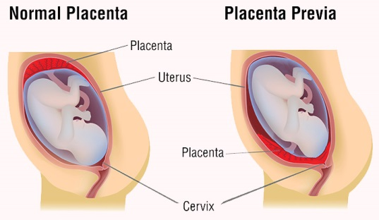

A woman with placenta previa requires a cesarean section to ensure healthy delivery of the baby. A cesarean section involves an incision made through the abdominal wall and uterus, allowing the baby to be removed from the mother.

* 1. Explain why a woman with placenta previa is required to have a cesarean section and cannot deliver her baby naturally? [2 marks]

*Any 2 points for 1 mark each*

* Placenta is needed to sustain baby till birth
* Placenta is blocking the birth canal
* Baby can go into distress
* If baby pushed through, placenta damaged / rupture before birth
* Caesarean stops this by removing baby
* Without going through cervix / no damage to placenta  
  1. The birth of a child can be summarised into the three stages of labour. In the table below, include the major events that occur in each of the stages. [3 marks]

*1 mark per box*

|  |  |
| --- | --- |
| **STAGE** | **EVENT** |
| 1. **Dilation** | Cervix dilates / gets bigger  Contractions start |
| 1. **Expulsion** | Delivery of baby |
| 1. **Placental** | Passing of placenta |

***EXTENDED RESPONSE [20 MARKS]***

1. Use the table to draw two graphs showing the masses off males and females at different ages. Draw the two graphs on the same graph grid on the next page. [6 marks]

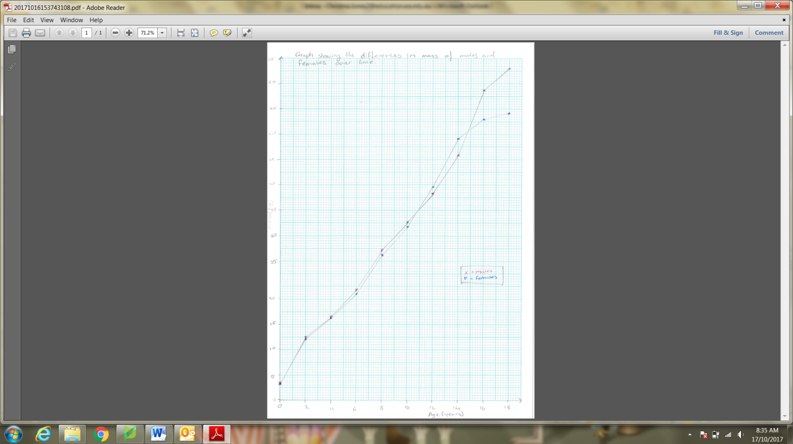*Include the following, 1 mark each*

* Labelled axes (x=Age, y=Mass)
* Units used (x=years, y=kg)
* Scale in equal intervals
* Title (includes relationship between Age and Mass)
* Legend and ruler
* Graph type (line)

Answer the following questions based on your graph.

1. Using the graph, identify any patterns, changes or trends in the mass of both males and females.

* Males: Steady growth then increase rapidly at 12 years
* Females: Steady growth then increases rapidly at 10 years, starts to slow down at 14 years

1. You should be able to see four stages of growth. Give an approximate age for the start and finish of each of these stages in males and females. [4 marks]

*1 mark per correct line*

|  |  |  |  |  |
| --- | --- | --- | --- | --- |
| STAGE | MALES’ AGES | | FEMALES’ AGES | |
| START | FINISH | START | FINISH |
| 1 | 0 | 2 | 0 | 2 |
| 2 | 2 | 12 | 2 | 10 |
| 3 | 12 | 16 | 10 | 16 |
| 4 | 16 | 18 | 16 | 18 |

1. Describe the pattern in growth in males and females in the first 10 years. [3 marks]

* Goes up/ increases. Same (1)
* Increases but slows. Similar (2)
* Steadily increases till around 2 y.o. then slows. Males on average weigh more (3)

1. Describe the difference in the pattern of growth in mass of males and females between 10 and 18 years old. [3 marks]

* Girls increase at faster rate then males (1)
* Females increase at a faster rate but plateau off as males increase growth rate (2)
* Females increase rate faster till about 16 y.o. whereas males increase growth rate at 14 and start to slow at 18 y.o. (3)

1. At what age does the adolescent growth spurt happen in:

* Males: 12 years
* Females: 10 years